Project  
Specification

Version 1.0 ● 29 June 2012

PROJECT SPECIFICATION

Telehealth

|  |  |
| --- | --- |
| VERSION: 1.0 | REVISION DATE: 16 June 2012 |

|  |  |  |  |
| --- | --- | --- | --- |
| **Approver Name** | **Title** | **Changes** | **Date** |
| Khoa Nguyen | Coder |  | 29 June 2012 |
|  |  |  |  |

Contents

Section 1. Overview 1

1.1 Purpose 1

1.2 Scope 1

1.3 User Characteristics 1

Section 2. Assumptions, Dependencies, Constraints 2

2.1 Assumptions 2

2.2 Dependencies 2

2.3 Constraints 2

Section 3. Requirements 3

3.1 Business Requirements 3

3.2 Functional Requirements 3

Section 4. Requirements Traceability Matrix 5

Section 5. References 6

Section 6. Glossary 7

Section 7. Appendices 8

# 

# Section 1. Overview

## 1.1 Purpose

This document is a guideline for all members of this project's group. All departments included designers, coders and business analysis need to follow this document to clearly understand project's long-term vision and short time targets.

## 1.2 Scope

This project develops a more timely, cost effective and results driven assessment and recommendation injury management tool.

## 1.3 User Characteristics

* Screening employees on remote sites immediately via a consultative approach. Enabling timely medical advice and follow up care of rehab advice.
* Enable transport communication between employee, medical/allied health provider and employer/contractor.
* Promote structured and medically appropriate return to work program.

# Section 2. Assumptions, Dependencies, Constraints

## 2.1 Assumptions

N/A

## 2.2 Dependencies

N/A

## 2.3 Constraints

N/A

# Section 3. Requirements

## 3.1 Business Requirements

* Background: companies operating in remote areas suffer from large medical diagnosis cost caused by medical screening and unnecessary travel cost.
* Success factors: This project contains 2 stages; complete the first stage is mandatory to proceed to the second stage.
  + Simple submit/receive system
  + Dashboard system for both patient’s side and doctor’s side.

## 3.2 Functional Requirements

### 3.2.1 Simple submit/receive system

#### 3.2.1.1 Purpose

Networking site provides:

* A place for photographer to expose their skills and talent.
* Unofficial CV site for designer/photographer through profiles and pages.
* Networking club via groups and social pages.
* Customized way to present user's photos and information.
* Updated news from friends, groups – better communication (notification for email, phone ...)

#### 3.2.*1*.2 Operations

1. Block diagrams

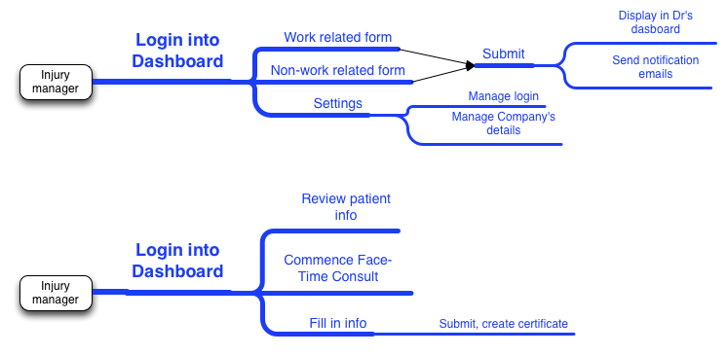

1. **Details**
   1. **Database**

* *Employer*: name, code, IMA, insurer, address, phone, email, login details
* *Employee:* name, DOB, sex, address, phone, occupation, date of injury, description of injury, location
* *ConsultingSession:* date, timeStart, timeStop, status, comments
  1. **Layout**

Start with a form at patient’s side.

### 3.2.2 Dashboard system

#### 3.2.2.1 Purpose

#### 3.2.*2.*2 Operations

# Section 4. Requirements Traceability Matrix

*Provide reference to the location of the Requirements Traceability Matrix that indicates traceabilty from the system requirements documented in the System Requirements Specification to the design elements documented in the System Design Description to the software requirements documented in this Software Requirements Specification (SRS).*

⇒

# Section 5. References

*Provide a list of all documents and other sources of information referenced in the SRS and utilized in developing the SRS. Include for each the document number, title, date, and author.*

| **Document No.** | **Document Title** | **Date** | **Author** |
| --- | --- | --- | --- |
|  |  |  |  |
|  |  |  |  |
|  |  |  |  |
|  |  |  |  |
|  |  |  |  |
|  |  |  |  |

# 

# Section 6. Glossary

*Define of all terms and acronyms required to interpret the SRS properly.*

⇒

# Section 7. Appendices

*Include any relevant appendices.*

⇒